Submitted by-

Name- Ishan Rawat

SAP ID- 500087524

Roll no- R2142201888

# Appl Containerization &Orchestration Lab Experiment 5

**AIM: Working with Dockerfile to Build and Push Docker Image**

**Step 1:** Create the Dockerfile

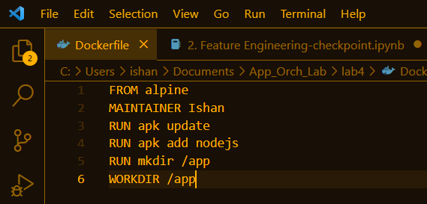

**Step 2:** Build image from Dockerfile

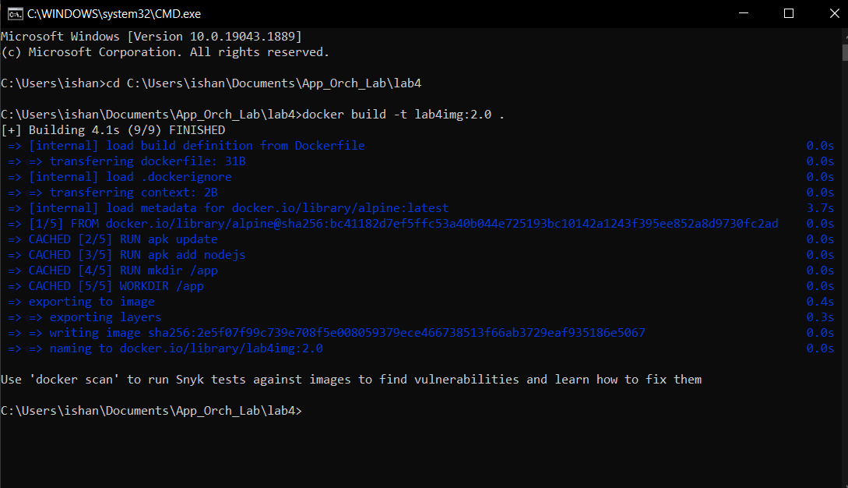

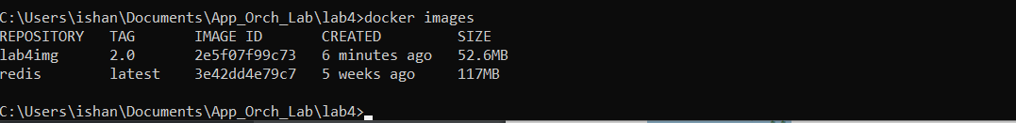

**Step 3:** Create an account on Dockerhub and create repository in it

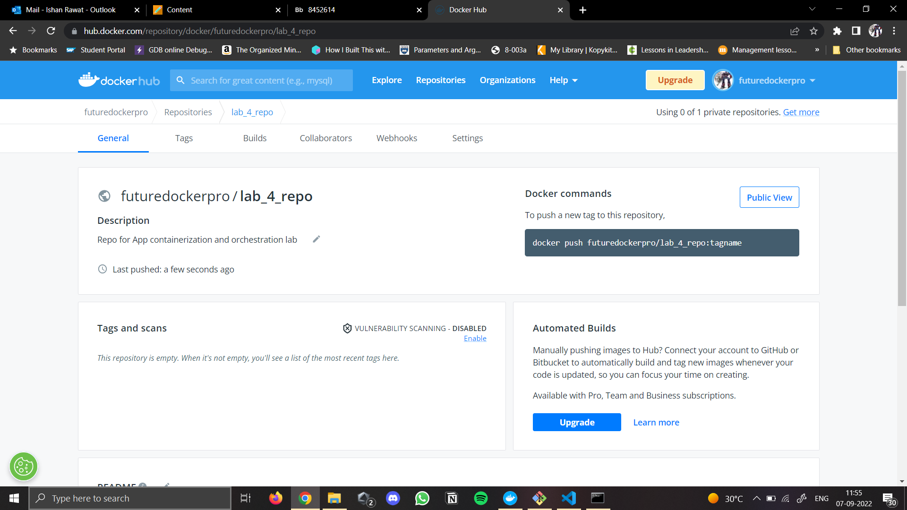

**Step 4:** tag the recently created docker image

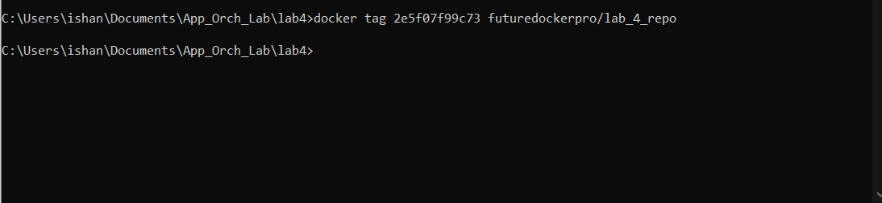

**Step 5:** login to Dockerhub from console

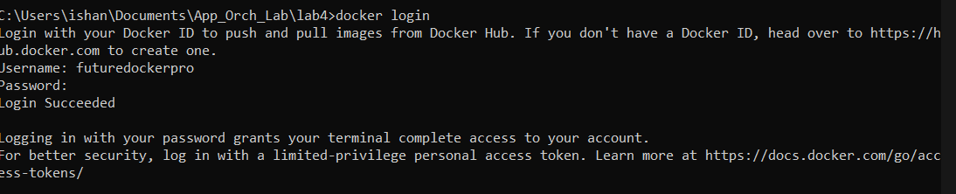

**Step 6:** push the image to Dockerhub

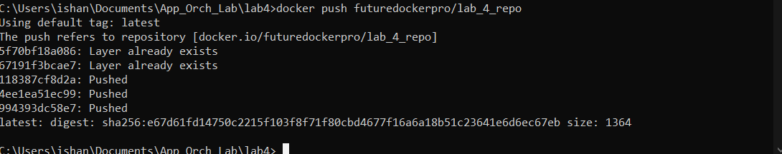

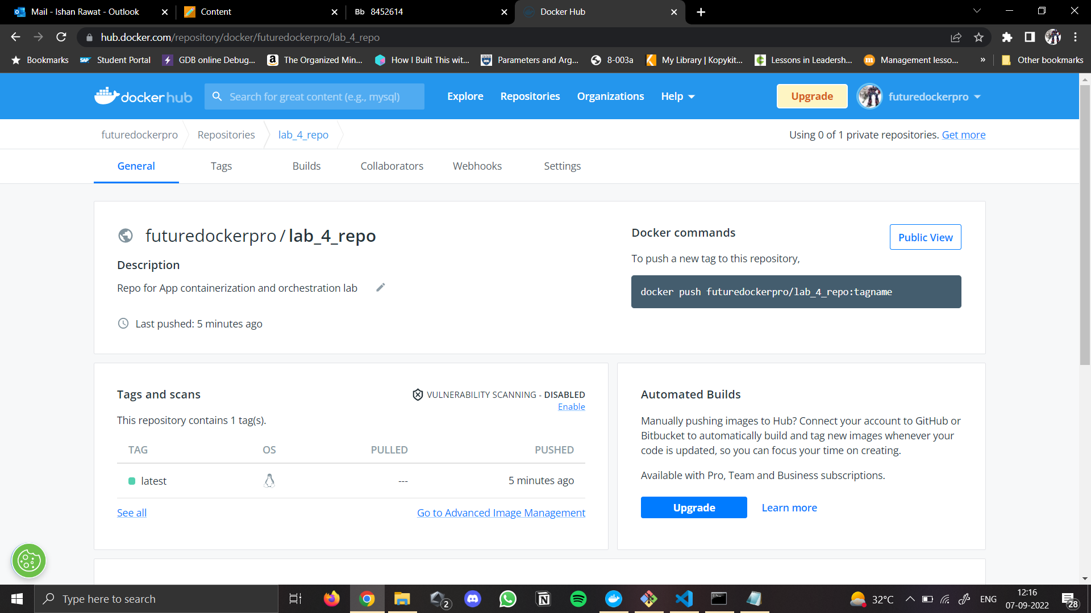

**Step 7:** Pull and run the image deployed on Dockerhub

